Cell Transport Practice Questions
1. Which of the following must be true for diffusion to occur?
A. Molecules or particles must have different sizes.
B. Special protein channels must always be available.
C. There must be areas of different concentrations.
D. Energy must be available.

2. Which term refers to the condition that exists when no net change in concentration results from diffusion?
A. concentration C. osmosis
B. equilibrium D. randomness

3. Air has a higher concentration of oxygen molecules than does the cytoplasm of your lung cells. Where in your lungs will there be a net increase of oxygen?
A. in the air breathed in C. outside of the lung cells
B. in the air breathed out D. inside of the lung cells

4. Which of the following statements tells how facilitated diffusion differs from simple diffusion?
A. Particles move through cell membranes without the use of energy by cells.
B. Particles tend to move from high concentration to lower concentration.
C. Particles move within channel proteins that pass through cell membranes.
D. Particles tend to move more slowly than they would be expected to move.

For Questions 5–7, match the situation with the result. Write the letter of the correct answer on the line at the left.

Situation
5. Cells are in an isotonic solution.
6. Cells are in a hypertonic solution.
7. Cells are in a hypotonic solution.

Result
- The cells lose water.
- The cells gain water.
- The cells stay the same
Water Flow Through a Semipermeable Membrane

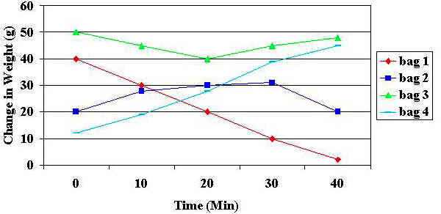

- What type of transportation is illustrated above?

- What type of solution were Bags 2 and 3 placed into? Use as many terms below to justify your answer.
isotonic, hypotonic, hypertonic, osmosis, high concentration, low concentration, mass, energy, ATP

- What type of solution was Bag 1 placed into? Use as many terms below to justify your answer.
isotonic, hypotonic, hypertonic, osmosis, high concentration, low concentration, mass, energy, ATP

- What type of solution was Bag 4 placed into? Use as many terms below to justify your answer.
isotonic, hypotonic, hypertonic, osmosis, high concentration, low concentration, mass, energy, ATP

- Most sports drinks are isotonic in relation to human body fluids. Explain why athletes should drink solutions that are isotonic to body fluids when they exercise rather than ones that are hypotonic to body fluids (contain a greater proportion of water in comparison to the fluids in and around human body cells).

- Your dad is preparing a vegetable tray for a party. He discovers that the celery in the refrigerator is no longer crisp. Based on information you learned during this inquiry how could your dad make the celery crispy and crunchy? Why do you think your plan will work?

- Using what you learned, explain what happens when you place a tea bag into a cup of hot water.

- Explain how cells use the processes of osmosis and diffusion to take in nutrients and get rid of wastes.

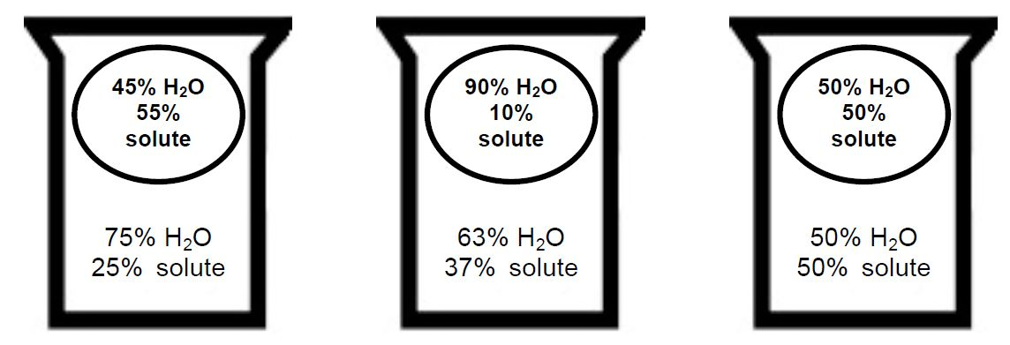
- Consult the pictures and directions below.
