Cell Cycle Practice Questions
- Locate the four mitotic stages and interphase.
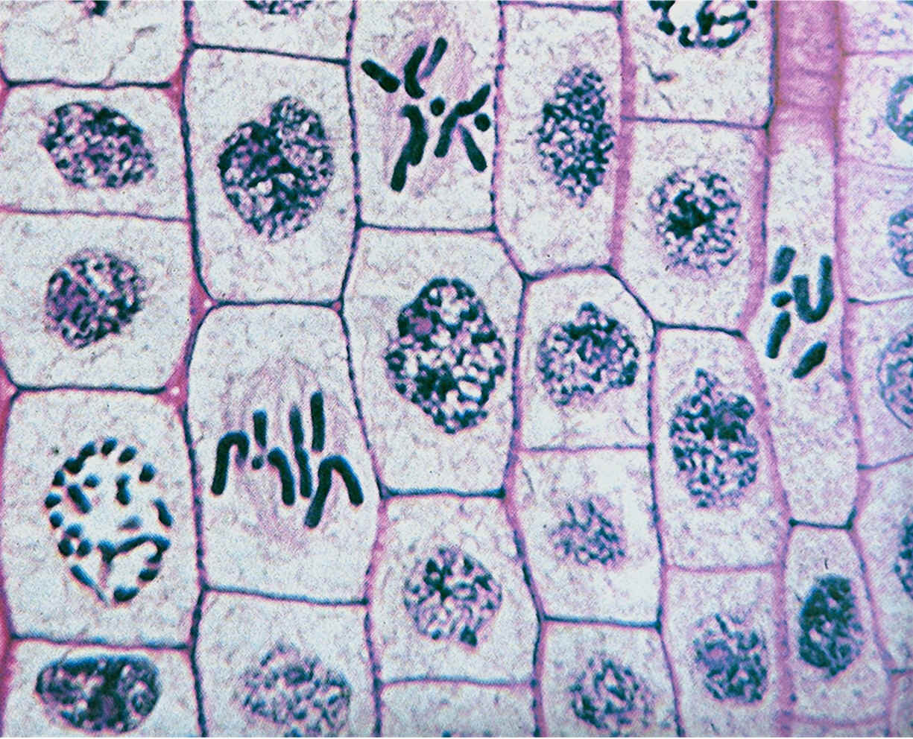

- Why is it necessary for the DNA to replicate prior to cell division?
- so that each daughter cell will have 23 chromosomes
- so that each daughter cell will have a complete copy of the genetic material
- so that each daughter cell will have 46 homologous chromosomes
- so that each daughter cell will have 2 sister chromatids

- Complete the following table and answer the following question
Cell | Surface Area | Volume | Ratio of Surface Area to Volume
1 | 42 cm2 |  | 7:1
2 | 78 cm2 | 13 cm3
3 |  | 16 cm3 | 5:1

  - Which cell is the most efficient at removing waste and taking in nutrients? Explain.

- Explain why the terms mitosis and cell cycle should not be used interchangeably.

- If a particular type of cell completes one cell cycle in 75 minutes, and you start with one cell, how many cells would be present after 7.5 hours?

- How does a plant cell differ from an animal cell during cell division?

- Do all cells in the body have the same growth rate? Give examples.

- Describe a situation in the human body that would cause an increase in the rate of cell division of certain cells, followed by a return to the normal rate of division.

- One the lines below, label the events in the cell cycle that correspond with the numbers in the diagram
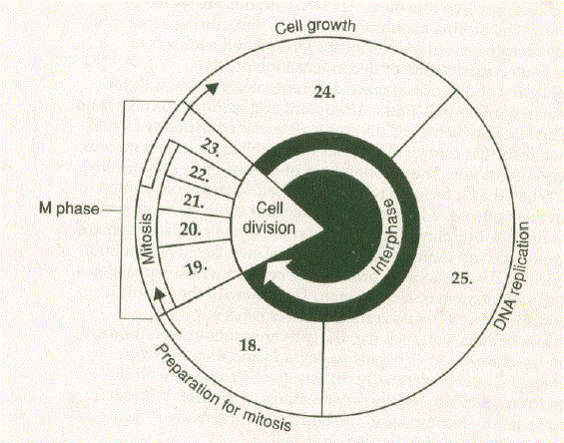
18. _______________________ 19. _________________ 20. ______________
21. ______________________ 22. ________________ 23. _______________
24. _________________ 25. ________________

- During certain stages of their life cycle, some cells repeatedly undergo mitosis but do not undergo cytokinesis. What would you expect to see if you looked at such cells, or a tissue made up of such cells, under a microscope? Explain your answer.

- Answer the following questions using the article below.
  - Why are prokaryotic cells considered to be simpler than eukaryotic cells?

  - What prompts a prokaryotic cell to stop replication and undergo cell division?

  - Do eukaryotic cells all divide at the same rate? If not, what controls the rate of division?

  - How is programmed cell death different from cell death as a result of injury or disease?

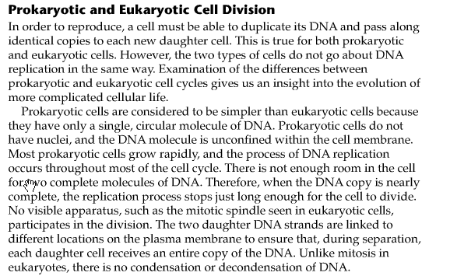
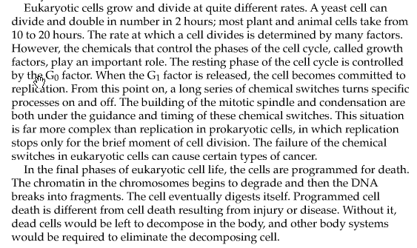
- Explain how drugs that alter cytoskeleton function would affect mitosis in animal cells.

- Explain why food poisoning is likely to occur if foods such as meats are sitting at room temperature for 30 to 60 minutes.

- Explain why diabetes, a condition in which glucose is not taken up readily by cells, slows down mitosis.

- Explain how amino acid deficiencies can affect the progression of the G1 phase of the cell cycle.

- What properties of a drug would selectively harm cancer cells without causing death or injury to normal body cells undergoing cell division?

- Design with a strategy that would inhibit binary fission without affecting the mitosis of microorganisms.

- Hair grows from hair follicles, pockets of continually dividing cells in the outer layer of the skin. New cells are added to the base of a hair shaft, inside each follicle. Use what you have learned in this lesson to explain why cancer patients often lose their hair when receiving chemotherapy and grow more hair after chemotherapy stops.

