Biomolecules Summary
 | Carbohydrates | Lipids | Proteins | Nucleic Acids
Elements | Carbon, hydrogen, & oxygen  CHO  (usually 1:2:1 ratio) | Carbon, hydrogen, & oxygen  CHO  (and phosphorus (P) for phospholipids) - CHOP | Carbon, hydrogen, oxygen, & nitrogen  CHON | Carbon, hydrogen, oxygen, nitrogen, & phosphorus  CHONP
Monomer | Sugar or glucose or  monosaccharide or simple sugar or C₆H₁₂O₆ | Fatty acids & glycerol  *not a true monomer  Triglycerides- 3 fatty acids & glycerol  Phospholipids- 2 fatty acids & glycerol | Amino acids  (20 different types due to a variable “R group”)  * contains an amino and carboxyl group | Nucleotides  * Phosphate group attached to a sugar molecule (ribose in RNA or deoxyribose in DNA) which is attached to a nitrogenous base (adenine, cytosine, guanine, thymine or uracil)
Structure of monomer | 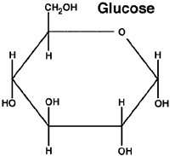 | Triglycerides  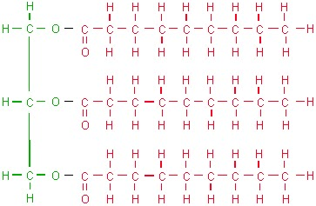  Phospholipids  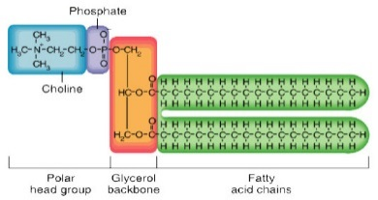 | 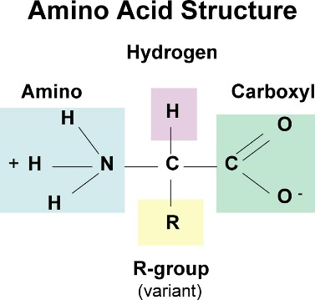 | Nucleotide  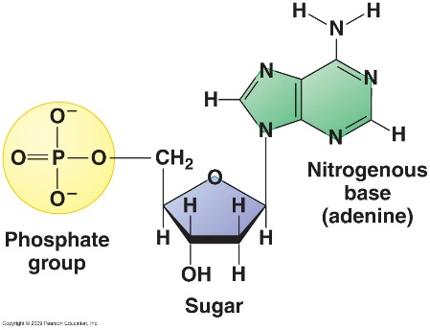
Function | * Quick energy  * Structural purposes in plants (cellulose cell wall), fungi (chitin cell wall), & insects (chitin exoskeleton) | * Store energy  * Part of biological membranes (phospholipids)  * Waterproof coverings  * Hormones, such as steroids | * Control the rate/speed of chemical reactions  * Transport substances into and out of cells  * Help fight disease | * Store and transmit genetic information  * Code for the production of proteins
Examples | Monosaccharides: glucose, galactose, & fructose  Disaccharides: sucrose, maltose, & lactose  Polysaccharides: plant starch, glycogen (equivalent of starch in animals), cellulose, & chitin | Phospholipids  Steroids  Fat  Cholesterol  Oil | Enzymes  Antibodies | DNA  RNA
Notes | * Polymers are held together by glycosidic bonds  * Made during photosynthesis in the chloroplasts  * Energy is released from sugar in cellular respiration in the mitochondria | * Saturated fats- has the maximum # of hydrogen atoms attached to every carbon atom. All the carbons are attached to each other with single bonds  * Unsaturated fats- not all carbon atoms are attached to a hydrogen atom  * Polar/hydrophilic head and non-polar/hydrophobic tails in phospholipids  * Synthesized at the smooth endoplasmic reticulum (SER) | * Amino acids held together by peptide bonds (di- or polypeptide)  * Has a specific shape that can denature (altered shape) when exposed to high temperatures and a significant change in pH  * Synthesized at ribosomes  * Primary structure -unique order of the amino acids joined together  * Secondary structure- coiling and folding of a polypeptide chain that gives the protein its 3-D shape – notably, α) helix and beta (β) pleated sheet  * Tertiary structure- comprehensive 3-D structure of the polypeptide,  * Quaternary structure- refers to the structure of a protein macromolecule formed by interactions between multiple polypeptide chains | * The 2 types of nitrogenous bases are purines (adenine and guanine) and pyrimidines (thymine and cytosine)  * Nitrogenous bases are held together by hydrogen bonds and nucleotides are held together by covalent or phosphodiester bond  * DNA is in the form of chromosomes which contain genes (which code for protein production)  * DNA is located in the nucleus in eukaryotes and is located in the cytoplasm in prokaryotes

