Animal Systems Practice Questions
- What happens if nerve cells sense that the core body temperature has dropped below 37^{O}C?

- Circle the letter of each activity that is controlled by the somatic nervous system
  - Beating of the heart
  - Lifting a finger
  - Wiggling the toes
  - Pulling foot away from tack
- How do the kidneys regulate blood pressure?

- How does the autonomic nervous system regulate blood pressure?

- What does a sudden increase in the number of white cells tell a physician?

- Use the table to answer the following questions
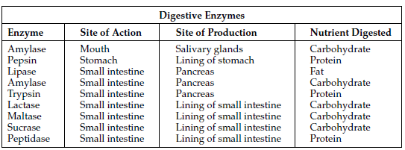
  - Where are the majority of digestive enzymes active?

  - Which organ or gland produces the greatest number of different enzymes?
  - Which digestive enzyme has more than one site of action and production?
  - Which digestive enzymes are active at a site different from the site where they are produced?
  - Which nutrient is digested by more enzymes than any other nutrient?

- Use the graph to answer the following questions
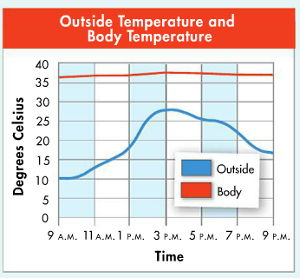
  - At what time of day is the body temperature closest to that of the outside environment?

  - What is the relationship between body temperature and the temperature of the environment?

  - How do you explain the shape of the graph for body temperature?

- The human digestive system converts food into glucose, a sugar that the body can use for energy. The following data were collected by taking a sample of blood from a person at various times during the day and measuring the relative volume of glucose into the blood
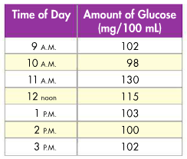
  - During which time interval is it most likely that this person ate a meal?
    - 9 am to 10 am iii. 10 am to 11 am
    - 1 pm to 2 pm iv. 2 pm to 3pm
  - Which value in the table would you expect to be closest to the homeostatic value for the amount of glucose in the blood? Explain.

  - Explain how feedback inhibition might be involved in the changing levels of glucose in the blood.

- Review the following information below to answer the corresponding questions.
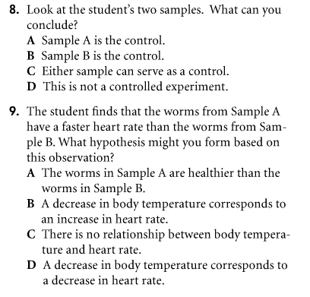
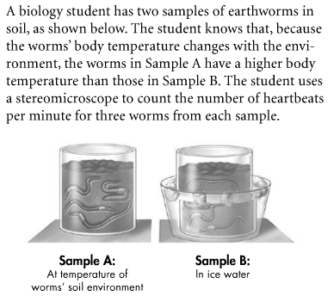
- Review the diagram below to answer the corresponding questions.
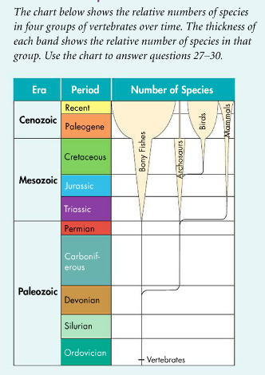
a. How is this kind of diagram similar to a traditional cladogram?

- What additional information can be learned from it?

- Which of the groups shown has the greatest number of species today?

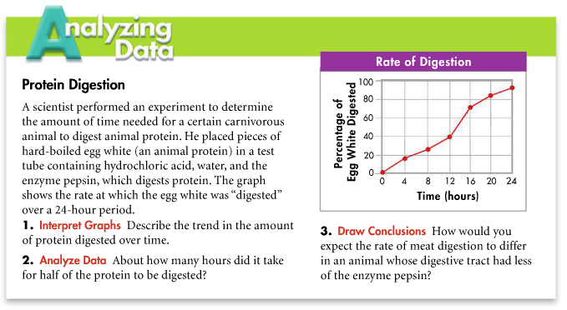
- Read the information below and answer the corresponding questions.
- Read the information below and answer the corresponding questions.

It started as an adventure. Some college buddies tried their own version of a “survivor” experience. During summer vacation, they were dropped off on an uninhabited tropical island, with minimal supplies. They would be picked up in a few days. The island was hot and dry, and they discovered that there was no fresh water. They knew that coconuts could provide fluids in the form of coconut “milk.” But one group member hated coconuts. He figured he’d get his fluids by drinking saltwater. At first, he was fine- although he was thirstier than his friends. Then, he became nauseated and weak. His condition worsened quickly. Soon he was seriously ill- with dizziness, headaches, and an inability to concentrate. His friends began to panic. What was happening?

Luckily, the pick-up the group arranged arrived earlier than planned. They rushed the sick man to a hospital, where he was diagnosed with severe dehydration and given water an intravenous fluids. If he had gone much longer without treatment, doctors told his friends, he would have died. What had happened? Why didn’t his friends suffer the same problems?

As sailors have known for centuries, humans can’t drink seawater for any length of time. But why can’t we drink seawater? Because seawater is saltier than human blood and bodily fluids, drinking it loads the body with excess salt. Human kidneys cannot produce urine with salt concentrations high enough to get rid of that salt efficiently. So the kidneys are forced to excrete more water in urine than the amount of salt water consumed. This lowers water body content to the point that blood literally becomes thicker and harder to push through fine capillary networks. Cells and tissues begin to dehydrate, and fatal kidney failure can result.
- While the group member who drank the seawater became seriously ill, the other group members’ experiences some water stress as well. What was going on in their circulatory and excretory systems, and why was it not as serious?

- If you were marooned on an island that had no fresh water, what would be your plan for getting some?

- Read the information below and answer the corresponding questions
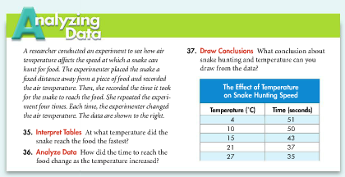
- Read the information below and answer the corresponding questions

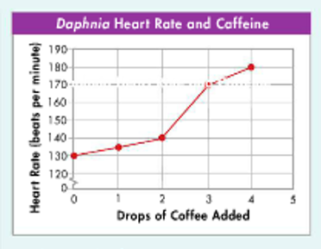
A student conducts an experiment to measure the effect of caffeine on the heart rate of a small pond-water crustacean called Daphnia. The heart of this animal is visible through its transparent shell. With the help of a dissecting microscope, the studet counts the heart-beats per minute before and after adding increasing amounds of coffee to the water surrounding the animal. Each data point in the graph at the top right represents the mean of five trials. Use the graph to answer the following questions.

a. Describe the effect of caffeins on the heart rate of Daphnia

b. What would be your prediction of the effect of five or more drops of caffeine on the heart rate of Daphnia?
- Read the information below and answer the corresponding questions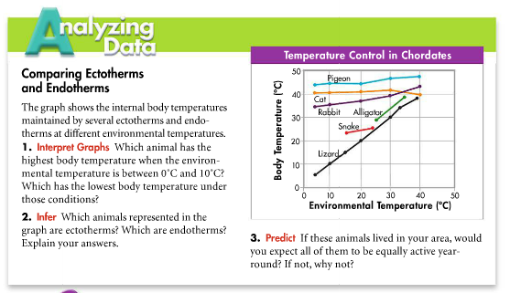

- When there is too much fluid in the blood, the heart must pump harder. Diuretics are substances that stimulate the kidneys to remove more fluid from the body. Why do you think diuretics are used to treat high blood pressure?

- Individuals who have had part, or even all, of their stomachs removed can survive if fed predigested food. Could these individuals also survive without a small intestine? Explain.

- 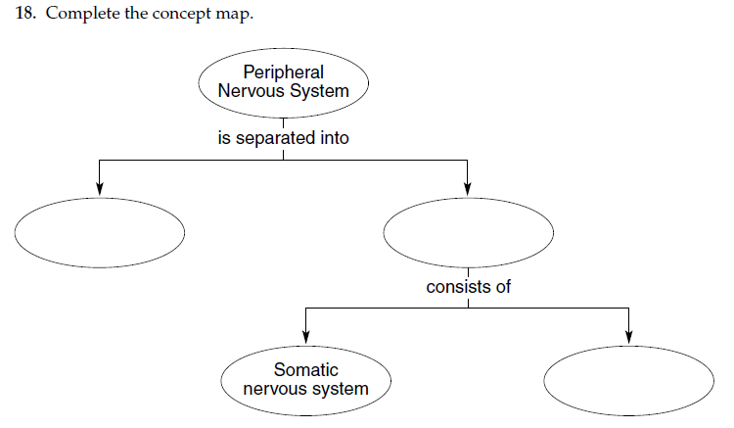

- 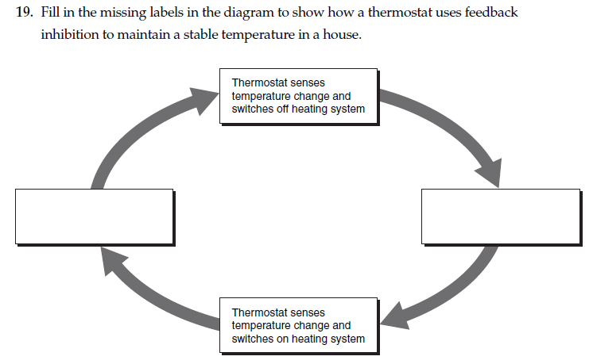

- Read the information below and answer the corresponding questions
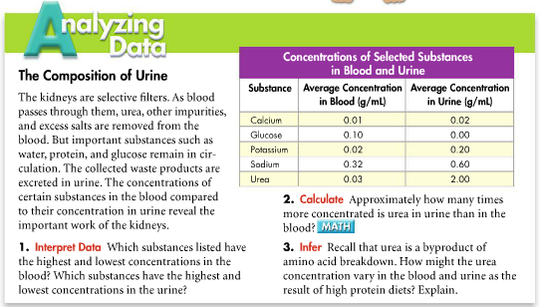

- Read the information below and answer the corresponding questions

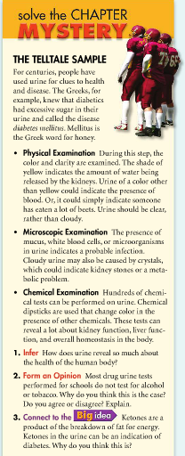

- Describe a situation in which you would expect your sympathetic nervous system to be more active than your parasympathetic nervous system.

- If you were standing, would you expect the blood pressure to be higher in your arm or in your leg? Explain your answer.

- Suppose the secretion of a certain hormone causes and increase in the concentration of substance X in the blood. A low concentration of X causes the hormone to be released. What is the effect on the rate of hormone secretion if an abnormal condition causes the level of X in the blood to remain very low?

- Read the information below and answer the corresponding questions
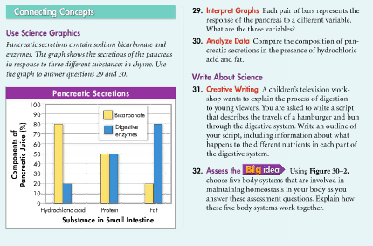

- Tobacco smoke can kill white blood cells in the respiratory tract, the cells that help keep the respiratory system clean by consuming debris. How do you think this contributes to the development of smoker’s cough?

- Why would a person with a low red blood cell count feel tired?

- Aspirin reduces the clot-forming ability of the blood. Why would a doctor prescribe aspirin for someone who has had a stroke?

- Read the information below and answer the corresponding questions
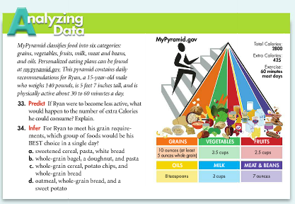

- 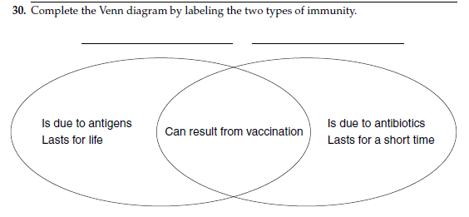

- A routine examination by a doctor usually includes a knee-jerk reflex test. What is the purpose of this test? Use a flowchart to show how the process occurs. What would the absence of a response indicate?

- People with emphysema cannot exhale as much carbon dioxide as people with healthy lungs. Why do you think this leaves them short of breath?
- How is the hypothalamus an important part of both the nervous system and the endocrine system?

- Explain how the endocrine system helps to maintain homeostasis.

- On a hot day, you play soccer for an hour and lose a lot of water in sweat. List the steps that your body takes to regain homeostasis.
- Read the information below and answer the corresponding questions
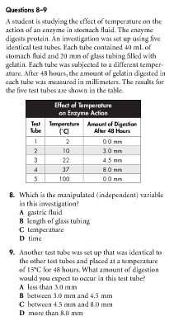

- Describe the relationship between the human circulatory system and the respiratory system. How does the proper functioning of those systems affect other body systems?

- The table shows the relative blood flow through some organs in the human body- that is, the percentage of blood that flows through a given organ. Through which organ(s) does all of the blood flow? Explain the effect of exercise on blood flow to skeletal muscles.
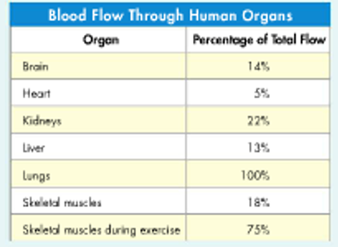
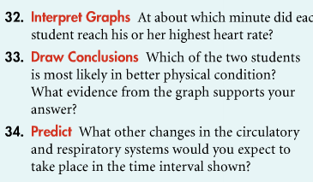
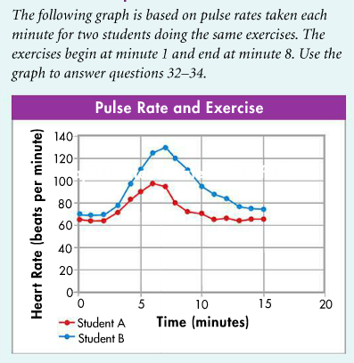
- Read the information below and answer the corresponding questions

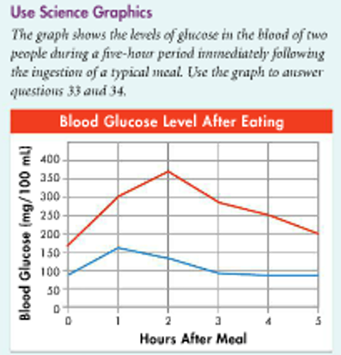
- Read the information below and answer the corresponding questions.

  - How long does it take the blood glucose level of the person represented by the blue line to return to a homeostatic value?

  - Which line represents a person who may have diabetes? Explain.

  - Which line represents a person who does not have diabetes? Explain.

- Read the information below and answer the corresponding questions.