Nucleic Acids Practice Questions

**DNA Structure**

1. Using the picture below, identify the following parts of the DNA molecule: hydrogen bonds, nucleotide, and sugar-phosphate backbone by placing the corresponding number below.



* 1. Hydrogen bond _________
  2. Nucleotide ________
  3. Sugar-phosphate backbone ________

1. A double helix looks like a twisted ladder. Which parts of a twisted ladder are analogous to the hydrogen bonds and sugar-phosphate backbones of a double helix of DNA?
2. Use Chargaff’s rules to determine the approximate percentage of thymine in a DNA molecule, if 28% of the nucleotides in the molecule contain adenine.
3. The drawing below to the right shows half of a DNA molecule. Fill in the appropriate letters for the other half.

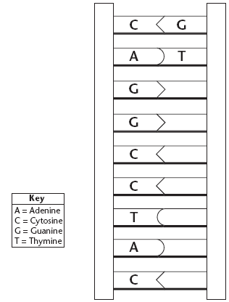

1. Complete the following sentences with the appropriate terms
   1. The building blocks of DNA are ________________ .
   2. Nucleotides in DNA are made of three basic components: a sugar called __________, a _______________ ___________, and a nitrogenous ____________.
   3. DNA contains four kinds of nitrogenous bases: ________ , ____, ___________, and _____________.
   4. In DNA, can be joined in any order.
   5. The nucleotides in DNA are joined by ____________ bonds.
   6. The nitrogenous bases in DNA are joined by ____________ bonds.
2. For Numbers 8–13, on the lines provided, label the parts of the DNA molecule that correspond to the numbers in the diagram.

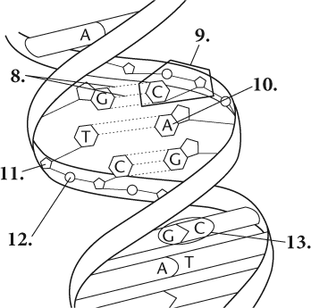

________



7. Examine the pictures below of DNA found in a virus, bacteria, fungi, and animal before answering the following questions.

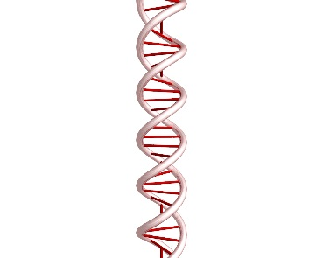Viral DNA Bacterial DNA Fungal DNA Animal DNA

1. What conclusion can you make about the DNA in viruses and all organisms?
2. Viruses, bacteria, fungi, and animals are all different, yet all are made of DNA with the same structure and function. Therefore, what part of the DNA is responsible for the differences among viruses and organisms as well as the diversity of the appearance of organisms?
3. Imagine you were a paleontologist and found the fossils of two organisms. You would like to determine whether each organism is closely related to the other using the DNA of each. How could a paleontologist use DNA to determine whether both organisms are closely or distantly related?
4. On Jerry Springer, many couples use paternity tests to determine who is the father of the child. To do so, each individual (the mother, child, and potential father) will use a buccal cotton swab to swab inside the cheek for 10 seconds. The DNA is then analyzed to determine paternity. If the DNA was taken from another part of the body (such as the skin, hair, or fingers), could the paternity of the child still be determined? Explain.

8. At the end of DNA replication, _______________ (four/two) new strands of DNA have been produced, giving a total of _________________ (four/six) strands of DNA.

9. On the lines corresponding to the numbers on the diagram, write whether the strand pointed to is an Original strand (O) or a New strand (N).

a. 4 _______

b. 5 _______

c. 6 _______

d. 7 _______

10. If the base sequence on a separated DNA strand is 5’ CGTAGG 3’, what will the base sequence on its complementary strand be?

11. DNA Replication occurs during S phase. Why is it important for DNA replication to occur before cell division?

12. Use the diagram to answer the questions below.



* 1. Which of the labeled strands are the parent strands? ________
  2. Which of the label strands are newly synthesized DNA? ________
  3. What nucleotide will be added to strand b next? ________
  4. What nucleotide will be added to strand c next? ________

13. Complete the flowchart for DNA replication according to the events listed below in the order in which they occur. Fill in the boxes with the correct letter:

1. DNA polymerase joins individual nucleotides to produce a new strand;
2. DNA helicase “unzips” and the two strands unwind;
3. DNA polymerase proofreads the new strands;
4. Unwound strands of DNA serve as templates for new DNA.